**ASSIGNMENT HTML/CSS**

**Harshit Kushmakar| 16896**

**1. Create the below given HTML Page using HTML5 and CSS**

<!DOCTYPE html>  
<html lang="en">  
<head>  
 <meta charset="UTF-8">  
 <meta http-equiv="X-UA-Compatible" content="IE=edge">  
 <meta name="viewport" content="width=device-width, initial-scale=1.0">  
 <title>Document</title>  
 <link rel="stylesheet" href="first.css">  
</head>  
<body>  
 <div class="navbar">  
 <ul>  
 <li><a href="#">Product</a></li>  
 <li><a href="#">Policy Setup</a><span></span></li>  
 <li><a href="#">Parameters</a><span></span></li>  
 <li><a href="#">Application</a></li>  
 <li><a href="#">Receipt</a></li>  
 <li><a href="#">Accounting</a><span></span></li>  
 <li><a href="#">Customer Service</a></li>  
 <li><a href="#">Report</a><span></span></li>  
 </ul>  
 </div>  
 <div class="container">  
 <h1>Create Allocation Priority</h1>  
 <form >  
 <div class="top-inputs">  
 <div class="Pname">  
 <label>Product Name</label><br>  
 <input type="text" id="Pname">  
 </div>  
 <div class="Pname">  
 <label for="Atype">Product Name</label><br>  
 <select name="Atype" id="Atype">  
 <option >Select one Option</option>  
 <option value="volvo">Volvo</option>  
 <option value="saab">Saab</option>  
 <option value="mercedes">Mercedes</option>  
 <option value="audi">Audi</option>  
 </select>  
 </div>  
 </div>  
 <br>  
 <div class="Pname">  
 <label>Allocation priority</label><br>  
 <input type="text" id="Harshit">  
 </div><br><br>  
 <label >Charge Inclusion</label>  
 <table>  
 <tr>  
 <th><input type="checkbox"></th>  
 <th>Charge Code</th>  
 <th>Priority</th>  
 </tr>  
 <tr>  
 <td><input type="checkbox"></td>  
 <td>InstallmentPrincipleComponent</td>  
 <td><input type="text"></td>  
 </tr>  
 <tr>  
 <td><input type="checkbox"></td>  
 <td>InstallmentilterestComponent</td>  
 <td><input type="text"></td>  
 </tr>  
 <tr>  
 <td><input type="checkbox"></td>  
 <td>LatePaymentPenality</td>  
 <td><input type="text"></td>  
 </tr>  
 <tr>  
 <td><input type="checkbox"></td>  
 <td>DisnursalCharge</td>  
 <td><input type="text"></td>  
 </tr>  
 <tr>  
 <td><input type="checkbox"></td>  
 <td>ProcessingFee</td>  
 <td><input type="text"></td>  
 </tr>  
 </table>  
 </form>  
 <br>  
 <hr>  
 <div class="btndiv">  
 <button class="btn">Save</button>  
 <button class="btn">Save & Request Approval</button>  
 </div>  
 </div>  
</body>  
</html>

**CSS:**

*{  
 margin: 0%;  
 padding: 0%;  
 box-sizing: border-box;  
 font-family: Arial, Helvetica, sans-serif;  
}  
  
.navbar{  
 border-bottom: 1px solid rgb(204, 200, 200);  
}  
  
  
.navbar ul {  
 list-style-type: none;  
 margin: 0;  
 padding: 0;  
 overflow: hidden;  
 background-color: #fbfafa;  
 }  
   
 .navbar ul li {  
 float: left;  
 }  
   
.navbar ul li a {  
 display: block;  
 color: rgb(12, 0, 0);  
 text-align: center;  
 padding: 14px 16px;  
 text-decoration: none;  
 }  
  
.container{  
 margin-top: 3vh;  
 margin-left:1vh;  
 margin-right: 20%;  
}  
.container h1{  
 font-weight: 400;  
 letter-spacing:-0.2vmin;  
}  
.top-inputs{  
 margin-top: 5vh;  
 display: flex;  
 justify-content: space-between;  
}  
input, #Atype{  
 padding:7px;  
}  
label{  
 letter-spacing:-0.1vmin;  
}  
table{  
 width: 100%;  
}  
table,th,td{  
 border:1px solid #ddd;  
 border-collapse: collapse;  
 padding: 8px;  
}  
table td{  
 width: max-content;  
}  
  
.btndiv{  
 margin:2vh;  
 display:flex;  
 justify-content:flex-end;  
}  
.btn{  
 background-color: #066deb;  
 margin-left: 5px;  
 border-radius: 4px;  
 color: #fbfafa;  
 padding: 9px;  
  
}

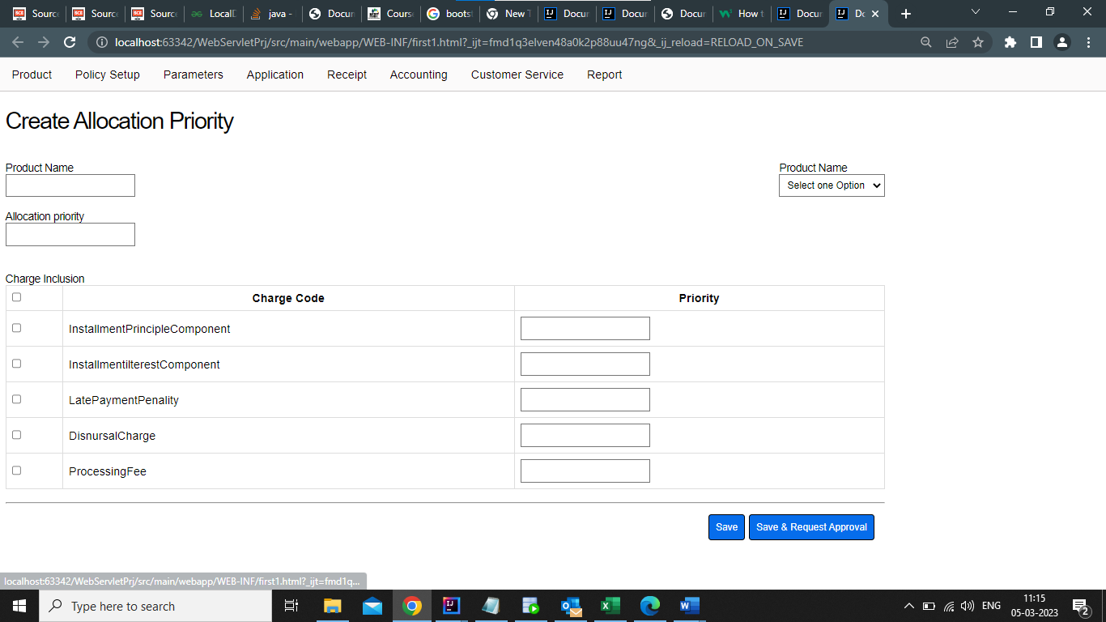

<!DOCTYPE html>  
<html lang="en">  
<head>  
 <meta charset="UTF-8">  
 <meta http-equiv="X-UA-Compatible" content="IE=edge">  
 <meta name="viewport" content="width=device-width, initial-scale=1.0">  
 <title>Document</title>  
 <link rel="stylesheet" href="second.css">  
</head>  
<body>  
 <div class="navbar">  
 <ul>  
 <li><a href="#">Product</a></li>  
 <li><a href="#">Policy Setup</a><span></span></li>  
 <li><a href="#">Parameters</a><span></span></li>  
 <li><a href="#">Application</a></li>  
 <li><a href="#">Receipt</a></li>  
 <li><a href="#">Accounting</a><span></span></li>  
 <li><a href="#">Customer Service</a></li>  
 <li><a href="#">Report</a><span></span></li>  
 </ul>  
 </div>  
 <div class="container">  
 <h1>Products</h1>  
 <button>New Product</button>  
 </div>  
 <hr>  
 <div class="mid-cont">  
 <div><label >Show</label><input type="number"><label>entries</label></div>  
 <div>  
 <label >Search: </label> <input type="text">  
 </div>  
 </div>  
 <table>  
 <tr>  
 <th>Product Code</th>  
 <th>Product Name</th>  
 <th>Product Description</th>  
 <th>Product Type</th>  
 <th>Created By</th>  
 <th>Status</th>  
 <th>Reviewed By</th>  
 <th>Actions</th>  
 </tr>  
 <tr>  
 <td>Data</td>  
 <td>Data</td>  
 <td>Data</td>  
 <td>Data</td>  
 <td>Data</td>  
 <td>Data</td>  
 <td>Data</td>  
 <td>Edit | Delete</td>  
 </tr>  
 </table>   
 <div class="bot-div">  
 <p>Sowing 1 to 1 of 1 entries</p>  
 <div class="btn">  
 <button>Previous</button>  
 <button id="btne">1</button>  
 <button>Next</button>  
 </div>  
 </div>  
  
  
 </div>  
</body>  
</html>

*{  
 margin: 0%;  
 padding: 0%;  
 box-sizing: border-box;  
 font-family: Arial, Helvetica, sans-serif;  
 margin-right: 1vh;  
}  
  
.navbar{  
 border-bottom: 1px solid rgb(204, 200, 200);  
}  
  
  
.navbar ul {  
 list-style-type: none;  
 margin: 0;  
 padding: 0;  
 overflow: hidden;  
 background-color: #fbfafa;  
 }  
   
 .navbar ul li {  
 float: left;  
 }  
   
.navbar ul li a {  
 display: block;  
 color: rgb(12, 0, 0);  
 text-align: center;  
 padding: 14px 16px;  
 text-decoration: none;  
 }  
  
.container{  
 margin-top: 5vh;  
 margin-left:1vh;  
 display: flex;  
 flex-direction: row;  
 justify-content: space-between;  
}  
.container h1{  
 font-weight:lighter;  
 letter-spacing: -0.2vmin;  
}  
.container button{  
 background-color: #066deb;  
 margin-left: 5px;  
 margin-bottom: 9vh;  
 border-radius: 4px;  
 color: #fbfafa;  
 padding: 9px;  
 border-color: #ddd;  
}  
label{  
 letter-spacing:-0.1vmin;  
 font-weight: 700;  
}  
table{  
 width: 100%;  
 margin-left: 1vh;  
 margin-left: 1vh;  
}  
table,th,td{  
 border:1px solid #ddd;  
 border-collapse: collapse;  
 padding: 8px;  
   
 align-content: center;   
   
}  
table td{  
 width: max-content;  
 justify-content: center;  
 align-content: center;  
 align-self: center;  
}  
.mid-cont{  
 display: flex;  
 justify-content: space-between;  
 margin-top: 4vh;  
 margin-bottom: 3vh;  
}  
input{padding: 5px;}  
.bot-div{  
 margin-top: 2vh;  
 margin-left: 1vh;  
 display: flex;  
 justify-content: space-between;  
}  
.btn button{  
 border-style: none;  
 font-size: medium;  
}  
#btne{  
 border:2px solid black;  
 margin: 3px;  
 padding: 5px;  
}

<!DOCTYPE html>  
<html lang="en">  
<head>  
 <meta charset="UTF-8">  
 <title>Assignment-2 | Question-2</title>  
 <link rel="stylesheet" href="third.css">  
</head>  
<body>  
<div class="top-nav">  
 <nav class="navbar">  
 <a href="#">Product</a>  
 <a href="#">  
 <select class="select-class">  
 <option>Policy Setup</option>  
 </select>  
 </a>  
 <a href="#">  
 <select >  
 <option>Parameters</option>  
 </select>  
 </a>  
 <a href="#">Application</a>  
 <a href="#">Receipt</a>  
 <a href="#">  
 <select>  
 <option>Accounting</option>  
 </select>  
 </a>  
 <a href="#">Customer Service</a>  
 <a href="#">  
 <select>  
 <option>Report</option>  
 </select>  
 </a>  
 </nav>  
</div>  
<div class="navbar">  
 <a href="CustmerInformation.html">Customer Information</a>  
 <a href="LoanInformation.html">Loan Information</a>  
</div>  
<hr>  
<br>  
<form name="customerInformation">  
 <div class="container">  
 <div class="A">  
 <div class="A1">Loan Application No.<span  
 style="color : red;">*</span> <br><input type="text" placeholder  
 size="30" name="ApplicationNo" required/></div>  
 <div class="A2">Product Type<span style="color :  
red;">*</span> <br>  
 <select class="sel" name="loanType" required >  
 <option>Auto Loan</option>  
 <option>Home Loan</option>  
 </select>  
 </div>  
 </div>  
 <br>  
 <div class="A">  
 <div class="A1">Product<span style="color :  
red;">*</span> <br>  
 <select class="sel" name="product">  
 <option>Select One Option</option>  
 </select>  
 </div>  
 <div class="A3">Loan Amount Requested<span  
 style="color : red;">*</span> <br><input type="text" placeholder  
 size="30" name="amount" required/></div>  
 </div>  
 <br>  
 <div class="A">  
 <div class="A1">Tenure(Months)<span style="color :  
red;">*</span> <br><input type="text" placeholder size="30"  
 name="tenure" required/></div>  
 <div class="A2">Rate <span style="color :  
red;">*</span> <br>  
 <input type="text" name="rate" placeholder  
 size="30" required/>  
 </div>  
 </div>  
 <br>  
 <div class="A">  
 <div class="A1">Agreement Date <br><input type="text"  
 name="AgreementDate" placeholder size="30"/></div>  
 <div class="A2">Installment Due Date<span  
 style="color : red;">*</span> <br>  
 <input type="text" name="InstallmentDueDate"  
 placeholder size="30" required/>  
 </div>  
 </div>  
 </div>  
 <br>  
 <hr>  
 <br>  
 <div class="button-div">  
 <button>Move To Next Stage</button>  
 </div>  
</form>  
</body>  
</html>

*{  
 margin : 0px;  
 margin-left : 0.2%;  
 }  
.top-nav{  
 background-color : #F3F4F9;  
 height : 70px;  
 margin-bottom : 30px;  
}  
.navbar {  
 padding-top : 2%;  
 margin-bottom: 4%;  
 margin-right: 2%;  
 margin-left: 2%;  
 color : black;  
}  
 a{  
 padding-top : 300px;  
 margin-right : 40px;  
 color : black;  
 text-decoration : none;  
 font-size : 20px;  
 }  
 h2{  
 font-weight : light;  
 margin-left : 20px;  
 }  
 .container{  
 }  
 .A{  
 display: flex;  
 margin-left : 20px;  
 margin-right : 100px;  
 }  
 .B{  
 margin-top : 25px;  
 font-weight: bold;  
 font-size : 18px;  
 margin-left : 20px;  
 margin-right : 100px;  
 }  
 .A1{  
 margin-left: 2%;  
 font-weight: bold;  
 font-size : 18px;  
 }  
 .A2{  
 margin-left : 60%;  
 margin-right: 7%;  
 font-weight: bold;  
 font-size : 18px;  
 }  
 .A3  
 {  
 margin-left : 66%;  
 font-weight: bold;  
 font-size : 18px;  
 }  
 .sel{  
 border:1px solid black;  
 }  
 .tabular{  
 border : 1px solid black;  
 width : 100px;  
 height : 100px;  
 border-collapse: collapse;  
 }  
 tr{  
 border : 1px solid black;  
 border-collapse: collapse;  
 }  
 td{  
 border : 1px solid black;  
 height : 30px;  
 padding-right : 30px;  
 }  
 th{  
 border : 1px solid black;  
 height : 15px;  
 padding-right : 135px;  
 width : 500px;  
 }  
 .checkbox{  
 padding-right : 50px;  
 padding-left : 10px;  
 padding-top : 5px;  
 }  
 .button-div{  
 margin-left : 70%;  
 margin-right : 7%;  
 font-weight : bold;  
 font-size : 18px;  
 border-radius : 7px;  
 color : white;  
 }  
 button{  
 height : 30px;  
 color : white;  
 background-color : #5361F6;  
 }  
 select{  
 background-color : #F6F6FC;  
 font-size : 18px;  
 border : 0px;  
 }  
 .priority{  
 padding-right: 420px;  
 }

